NORDIC UNION OF ART AND MUSIC SCHOOLS
Nordisk Musik- och Kulturskola unionen NMKU
www.nordicmusicartschools.org
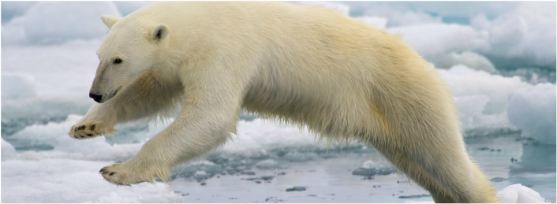

Nordic Co-operation and the Nordic region
- We have one of the oldest and most wide-ranging forms of regional political collaboration, and we aspire to be the most integrated region in the world
- The Nordic Council is a geo-political inter-parliamentary forum for co-operation between the Nordic countries. It was formed after the Second World War in 1952 to promote co-operation between the five Nordic countries. Its first concrete result was the introduction in 1952 of a common labour market and free movement across borders without passports for the countries' citizens
- The Nordic Council of Ministers was founded in 1971
- We are the 11th largest economy in the world
- We have one of the most highly educated populations in the world. We are strongly committed to working together on research both within the region and with international partners, e.g. on combating the consequences of climate change
- We top many international rankings. We lead the world in transparency, trust, the environment, gender equality and happiness
- Common language
- Since 1991 Estonia, Latvia and Lithuania participate with observer status, as well as the German state of Schleswig-Holstein since 2016.

Who we are – NMKU

- Nordic Union of Art and Music Schools is a network for the national organizations of music and art schools in Denmark, Finland, Norway and Sweden with close contacts to music and art schools in Iceland, Faroe Islands, Greenland and Aaland
- NMKU was founded/ initiated around 2009, more regular activity since 2014
- Music and culture school leaders from the Nordic countries and Estonia
- Without mandate
- In 2017 Estonia became a new member of the network
- During 2017 Norway is head of the network

DENMARK
Benedicte Christiansen, Head of secretary, Association of Danish Music and Art Schools, DMKL
Nina Ulf Jørgensen, Head of secretary, Danish Association of Music Schools
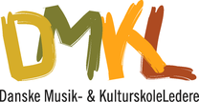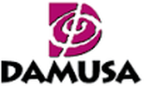

NORWAY
Lars Emil Johannessen, Advisor, Norwegian Association of Art Schools

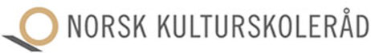
FINLAND
Timo Klemettinen, Managing Director, Association of Finnish Music Schools
Bo-Anders Sandström, Board Member, Association of Finnish Music Schools

SWEDEN
Torgny Sandgren, Head of Secretary, Swedish Council of Schools for Music and the Arts

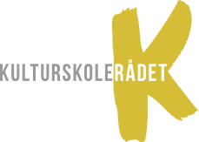

ESTONIA
KADRI LEIVATEGIJA, President, Estonian Music Scools Union
Silja Aavik, Board Member EMU
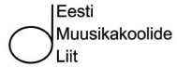
What we do
- Aims to develop the arts education of children and young people in the context of Nordic countries
- Regular meetings four times per year
- Mind Mapping
- Comparative statistics
- The purpose is to learn from each other
- Nordic Music and Arts Education Conferences
The conference is part of the official programme of the Nordic Council of Ministers
Aalborg, Danmark, september 2015
Helsinki, Finland, september 2016
Oslo, Norway. september 2017

Common challenges - Challenges for the music and art schools in a Nordic perspective
Fair Arts Education - how the quality and accessibility work together as concepts in the field of teaching arts
Arts Education for all – Equal access to music education
Arts Education in the Future – Curriculum or not, what do our costumers expect
Economic Challenges - When cooperation between primary school and music schools becomes a must

